TESTING DOCUMENT
Sprint 1 – Coin Converter Python Program

1. Introduction
Testing is one of the most important stages in the software development lifecycle because it helps verify whether a system performs according to the specified requirements. The purpose of testing in this project was to ensure that the Coin Converter Python Program correctly interprets pseudo-English statements describing quantities of coins and accurately converts them into dollar amounts Panichella et al., (2022).
The testing phase focused on validating the functionality, accuracy, reliability, and stability of the application under different input conditions. Multiple test cases were executed to determine whether the program could successfully process singular and plural coin denominations, multiple denominations within a sentence, and different quantity values Panichella et al., (2022). The testing process also aimed to identify possible errors or bugs within the system and confirm that corrections made during development improved the performance of the application.
2. Objectives of Testing
The primary objective of testing was to verify that the system calculates correct dollar amounts from pseudo-English coin statements. The testing phase also aimed to ensure that the application correctly recognizes supported denominations including pennies, nickels, dimes, and quarters.
Another objective was to confirm that the system processes sentences containing multiple denominations connected using the word “and.” The testing process also evaluated whether the program could handle both singular and plural forms of the supported coin names.Additionally, testing was conducted to ensure that the output generated by the system is properly formatted with two decimal places and that the program remains stable during execution.

3. Testing Procedure
The testing process involved running the Python program and entering predefined pseudo-English statements as input. After the input was processed, the actual output generated by the system was compared with manually calculated expected results.
Each test case was evaluated individually to determine whether the system produced the correct output. If the actual output matched the expected output, the test case was marked as passed. If the results differed, the test case would be marked as failed and further debugging would be performed. The testing process was repeated multiple times using different combinations of quantities and denominations to verify consistency and accuracy.

4 Test Cases and Results
Table 1: Test Cases and Results
Test Case Input | Expected Output | Actual Output | Result
1 penny and 2 nickels | $0.11 | $0.11 | Passed
4 dimes and 7 quarters | $2.15 | $2.15 | Passed
1 quarter and 3 pennies | $0.28 | $0.28 | Passed
21 pennies and 17 dimes and 52 quarters | $14.91 | $14.91 | Passed
95 dimes and 73 quarters and 22 nickels and 36 pennies | $29.21 | $29.21 | Passed
1 nickel and 17 quarters | $4.30 | $4.30 | Passed
21 nickels and 15 pennies | $1.20 | $1.20 | Passed
1 dime and 1 nickel and 1 penny and 1 quarter | $0.41 | $0.41 | Passed
5 quarters | $1.25 | $1.25 | Passed
100 pennies | $1.00 | $1.00 | Passed

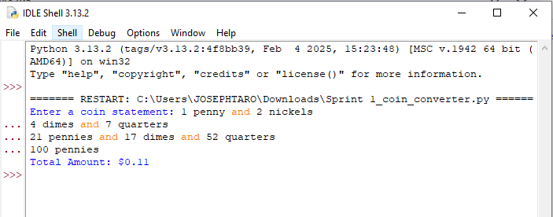

5. Testing Analysis
The results obtained during testing confirmed that the system correctly interprets pseudo-English coin statements and calculates accurate dollar amounts. All test cases executed during Sprint 1 produced outputs matching the expected values.
The testing process demonstrated that the program successfully supports multiple denominations within a single sentence and accurately processes connector words such as “and.” The system also handled large quantity values effectively without affecting calculation accuracy. Additionally, the testing results confirmed that the output formatting functionality works correctly by displaying all results with exactly two decimal places.

6. Bugs Identified
During the initial stages of testing, one issue was identified involving capitalization differences in user input. The original implementation failed to process uppercase coin names correctly because comparisons were case-sensitive. (1 DIME and 2 QUARTERS)
The issue occurred because the program compared words exactly as they were entered by the user. To resolve this problem, the implementation was updated to convert the entire input sentence into lowercase before processing. After applying this correction, the system successfully handled both uppercase and lowercase inputs without errors. No additional functional bugs were identified during Sprint 1 testing.

7. Challenges Encountered During Testing
One of the main challenges encountered during testing was ensuring that the system correctly handled both singular and plural coin denominations. Additional testing was required to confirm that denominations such as “penny” and “pennies” produced the same monetary value Herbold et al., (2022).
Another challenge involved verifying that the connector word “and” did not interfere with calculations. Multiple sentence variations were tested to ensure that the system ignored unnecessary words while maintaining calculation accuracy. Despite these challenges, the final implementation performed successfully for all tested scenarios.

8. Conclusion
The Sprint 1 testing phase successfully verified that the Coin Converter Python Program meets the specified functional requirements. The system accurately interpreted pseudo-English statements, processed quantities and denominations correctly, and generated properly formatted dollar outputs Herbold et al., (2022).
All test cases passed successfully after correcting the capitalization issue identified during testing. The results demonstrated that the application is stable, reliable, and capable of producing accurate monetary calculations for valid inputs. The successful completion of the testing phase confirms that the system is ready for the next stage of development and further improvements if necessary.

References
Herbold, S., Haar, T., Trautsch, A., & Grabowski, J. (2022). Smoke testing for
machine learning: Simple tests to discover severe bugs. Empirical Software
Engineering, 27(45). https://doi.org/10.1007/s10664-021-10073-7
Panichella, A., Panichella, S., Fraser, G., Sawant, A. A., & Hellendoorn, V. J. (2022).
Test smells 20 years later: Detectability, validity, and reliability. Empirical
Software Engineering, 27(170). https://doi.org/10.1007/s10664-022-10207-5

